 | INTERNATIONAL TELECOMMUNICATION UNION  TELECOMMUNICATION  STANDARDIZATION SECTOR  STUDY PERIOD 2025-2028 |  | Focus Group on AI Native for Telecommunication Networks  (FG-AINN)
 |  |  | FG-AINN-I-XXX
 |  |  | Original: English
Question(s): |  | N/A | New Delhi, 11-13 June 2025
INPUT DOCUMENT
Title | AI-Native Proactive Network Slice Marketplace for Dynamic Service Ecosystems
Contact: | Priyadarsini K  SRM Institute of Science and Technology  India | Tel: 97915 15576  Email: priyadak@srmist.edu.in
Contact: | Sorna Lakshmi. K  SRM Institute of Science and Technology  India | Tel: 87545 46127  Email: sornak@srmist.edu.in
Contact: | Harsh Sahu  SRM Institute of Science and Technology  India | Tel: 93990 73131  Email: hs3657@srmist.edu.in

Abstract: | The AI-Native Proactive Network Slice Marketplace redefines telecom operator-enterprise collaboration in the 5G/6G era by integrating industry-standard architectures with state-of-the-art AI models. Building on frameworks such as the FreeMove Alliance, this platform introduces a dynamic marketplace where enterprises can procure tailored network slices with guaranteed Service Level Agreements in real time. This Marketplace utilize advanced foundation models for intelligent network slice selection. Predictive components utilize Time Series Transformers for demand forecasting. These AI upgrades allow self-managing and context-aware slices that adapt to changes in demand and network conditions while ensuring transparency and regulatory alignment.

- Introduction

In the evolving landscape of next-generation networking, dynamic and intelligent allocation of network slices is critical to meeting diverse Quality of Service (QoS) requirements. This system introduces a Customer API Layer that enables clients to submit slice requests specifying constraints such as latency, throughput, and reliability. A Slice Vendor Registry maintains an up-to-date list of vendor APIs, supporting real-time registration and deregistration of slice offerings. At the core of the architecture is an AI-Orchestrator Module powered by a Large Language Model (LLM). This module acts as the endpoint for AI inference.
The orchestrator parses customer intents, evaluates available vendor slices, and applies a multi-criteria decision-making model to select the optimal slice. The selection process balances key factors including QoS Match Score (assessing latency, jitter, packet loss, and bandwidth), cost efficiency, slice availability, deployment time, and vendor reputation based on historical performance metrics. It is further enhanced to:
- Engage in real-time negotiation with vendor APIs
- Leverage a knowledge base for context-aware decisions
- Support self-managing network slices through real-time adaptation
- Information Exchange Between Application and Model
The information exchange between the application and AI model happens via the Customer API Layer using structured formats such as JSON. Key details include:
- Application types (e.g., video streaming, remote surgery)
- SLA constraints (latency, jitter, bandwidth, reliability)
- Priority flags or use-case identifiers
The data is parsed into machine-understandable vector representations, and responses are returned in structured JSON format with slice details, performance expectations, and configurations. Intermediate formats such as CSV/Excel are used for logging KPIs.

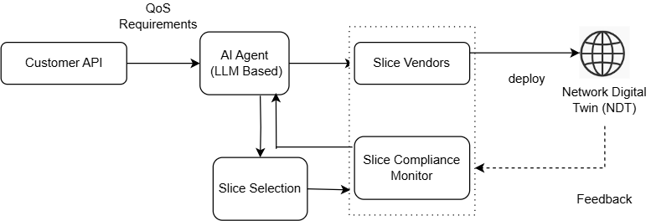

Figure: AI-Native Proactive Network Slice Marketplace

AI Techniques Used

The system employs a multi-layer AI architecture comprising:

- Agents: LLM-based agents for intent parsing and slice negotiation
- Reinforcement Learning: DQN and Actor-Critic networks for resource allocation
- Multi-Agent Systems: For coordinating resource sharing and trade-offs
- Supervised Models: Ensemble classifiers for traffic categorization
- Forecasting Models: Transformers and LSTM-autoencoders for demand and anomaly prediction
- Generative Models: GANs for synthetic traffic generation

Application Use Case Example – Autonomous Vehicles
Scenario: Smart city deployment involving autonomous vehicles
Application Requirements:
Ultra-low latency (< 5 ms)
High reliability and seamless mobility support
AI Processing Steps:
- Application input specifies "autonomous vehicle"
- AI agent interprets intent and selects URLLC-class slice
- Orchestrator assesses vendor options using multi-criteria decision logic
- Slice is provisioned dynamically with proactive scaling
- Real-time monitoring ensures SLA compliance
- Implementation Approaches
A modular architecture integrates:
- A 5G Network Slice Simulator
- The AI-Orchestrator Endpoint
- A Knowledge Base
- Metrics Engine
Training occurs on synthetic and real-world datasets. Evaluation engines measure KPIs and support test scenarios such as:
- AI vs non-AI performance comparison
- Real-time resource adaptation
- Scenario-specific dynamic response (e.g., stadium peak load, smart city coordination)

Submission Id | FG-AINN-PoC-xxx  (Id number is to be assigned by the secretariat)
PoC Objective | Primary Goal: Develop and demonstrate an AI-native proactive network slice marketplace that autonomously optimizes 5G network resources through intelligent orchestration, predictive analytics, and real-time adaptation.  Core Value Proposition:  - Proactive Intelligence: AI predicts and prevents network congestion before it occurs  - Autonomous Operation: Self-managing network slices with minimal human intervention  - Dynamic Optimization: Real-time resource reallocation based on traffic patterns and SLA requirements  - Intent-Based Networking: User intents are automatically translated to network configurations.  Technical Innovation Framework  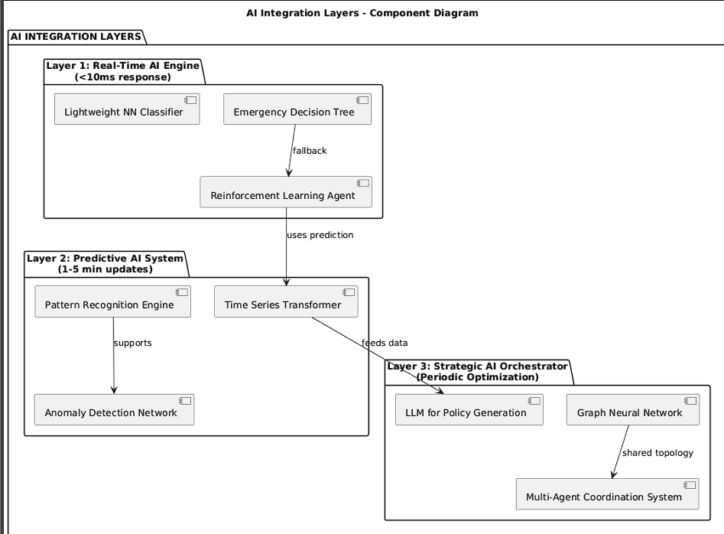  Multi-Layer AI Architecture:  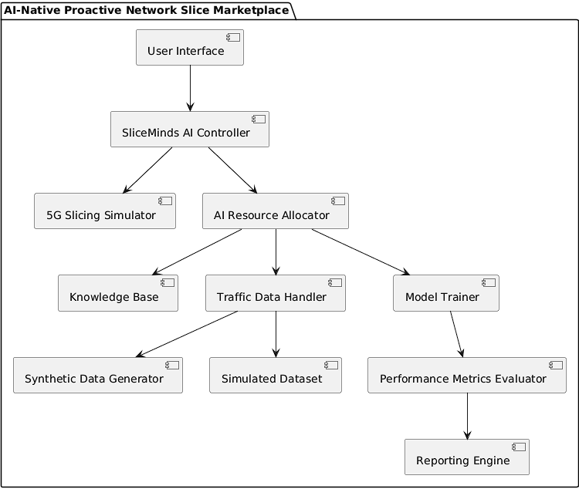
PoC Setup | Primary Data Sources:  - Synthetic Traffic Generation: AI-generated realistic network patterns using GANs  - Real-world Inspired Patterns: Based on published 5G network studies  - Dynamic Load Scenarios: Peak hours, emergency situations, sporting events  - Multi-dimensional Traffic: Video streaming, IoT bursts, autonomous vehicle data, industrial IoT  Advanced AI Model Suite  1. Real-Time Decision Engine:  - Deep Q-Network (DQN): For dynamic resource allocation decisions  - Actor-Critic Networks: For continuous action space optimization  - Ensemble Classifiers: For traffic type identification and priority assignment  2. Predictive Analytics Suite:  - Transformer Models: For time series forecasting  - LSTM-Autoencoder: For anomaly detection and pattern analysis  3. Strategic Optimization Layer:  - Large Language Models: For priority/scenario based slice selection  - Multi-Agent Reinforcement Learning: For inter-slice coordination  4.AI Agent and Orchestrator Endpoint  The AI Agent, which is LLM-based, is integral to the AI-Orchestrator Module. This module sits at the core of the architecture and acts as the endpoint for AI-based inference.  - Enhancements to this orchestrator endpoint include its ability to:  - Engage in real-time negotiation with vendor APIs.  - Leverage a knowledge base for more context-aware decision-making.  - Support self-managing network slices through real-time adaptation capabilities  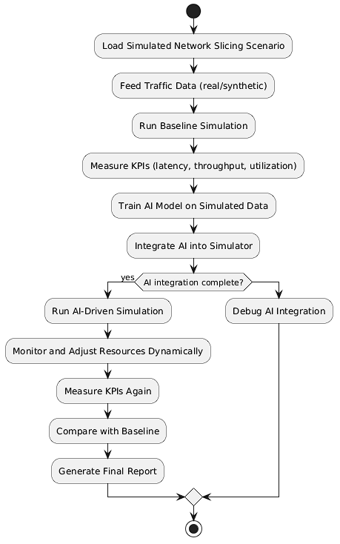
PoC  demo and Success Criteria | 4.1 Advanced Demonstration Scenarios  Scenario 1: Baseline Performance Benchmarking  - Setup: Uniform network load across all slice types  - Metrics: Establish baseline latency, throughput, and resource utilization  - Simulation with consistent traffic patterns  Scenario 2: AI-Driven Dynamic Optimization  - Traffic Pattern: Dynamic daily traffic patterns reflecting real-world user behaviour.  - AI Response: Proactive resource pre-allocation based on predicted demand  Scenario 3: Emergency Response Simulation  - Trigger: Simulated natural disaster with emergency vehicle deployment  - AI Behaviour: Instant prioritization of the correct slice type with dynamic resource reallocation.  - Success Metric: Reduced latency maintained for critical communications  Scenario 4: Smart City Integration  - Complex Scenario: Simultaneous autonomous vehicles, IoT sensor networks, and citizen mobile usage  - AI Coordination: Multi-agent system managing competing resource demands  - Innovation: Cross-slice resource borrowing and lending  Scenario 5: Stadium Event Peak Load  - Challenge: Supporting large-scale concurrent access during live event.  - AI Solution: Predictive scaling and load balancing across multiple cell towers  - Demonstration: Maintain QoS while handling increased traffic surges.  4.2 Enhanced Success Criteria  - Latency Reduction  - Resource Efficiency:  - Improved overall resource utilization  - Reduced energy consumption  - Adaptability Metrics:  - Faster Response time to traffic changes  - Improved prediction accuracy  - Reduced SLA violations  Information Exchange: Application and Model  The information exchange between the application (e.g., an enterprise requesting a slice) and the AI model occurs via the Customer API Layer using structured formats, primarily JSON.  Key details exchanged include:  - Application types (e.g., video streaming, remote surgery).  - SLA constraints such as latency, jitter, bandwidth, and reliability.  - Priority flags or use-case identifiers.  This data is parsed into machine-understandable vector representations. The AI model's responses, containing slice details, performance expectations, and configurations, are also returned in a structured JSON format. For logging Key Performance Indicators (KPIs), intermediate formats like CSV/Excel are used
PoC Plan and Report | Stage-1: demo proposal by May 27, 2025  Stage-2: implementation proposal and test cases by May 30, 2025  Stage-3: initial implementation by June 11, 2025  Stage-4: Final demo and report in FG AINN template by June 13, 2025
Created by | Team: SliceMinds  Team lead: Priyadarsini K  Team member: Priyadarsini K  Sorna Lakshmi K  Harsh Sahu  Internal guide: Prof. Revathi Venkataraman
Creation date | 29-05-2025
Open problems and future study | Future Study  - Testing in a real time 5G environment.  To validate the effectiveness and practical viability of the AI-Native Proactive Network Slice Marketplace, future research should focus on deployment and testing within an operational 5G network setting.  - Integrating Explainable AI  Incorporating Explainable AI (XAI) into the AI-Native Proactive Network Slice Marketplace is crucial to clarify why the AI models select certain network slice types in response to given traffic patterns or enterprise requirements.

Stage 2: Implementation Proposal

Implementation Approaches | We propose a modular architecture with clear separation between simulation, AI control, and performance evaluation. The solution integrates:  - A 5G Network Slice Simulator that generates and manages virtual slices with adjustable parameters (latency, bandwidth, etc.).  - An AI-Orchestrator Module trained to proactively allocate resources based on traffic patterns.  - A Knowledge Base for context-aware decision-making.  - A Metrics Engine to evaluate throughput, utilization, latency, and energy efficiency.
Test Setup | - Environment: Jupyter Notebook / Google Colab, optionally extended to AWS EC2 for large-scale experiments.  - Simulator: Python-based network slice simulator capable of emulating traffic conditions across multiple slices.  - Model Training: Transformer / LSTM-based models trained on synthetic and real-world-like datasets.  - Evaluation Engine: Integrated module for real-time and post-simulation KPI measurement.
Functional and Performance Requirements.  Datasets
   | Category | Requirement Description
   | Functionality | Simulate 5G slices, deploy AI model, measure KPIs, and dynamically adjust resources
   | Performance | Optimize latency, improved resource utilization.
   | Scalability | Support >50 concurrent slices with real-time resource decisions
   | Accuracy | Prediction accuracy of traffic needs
  Dataset Source Description
  Synthetic Dataset |  |  | Generated using traffic models for eMBB, URLLC, mMTC slices across time slots
  Simulated Dataset |  |  | Data collected from custom simulator runs with variable loads
  Optional Real Data |  |  | Public 5G traffic traces if integration time allows
Toolsets
  Tool/Framework | Purpose
  Python | Core simulator, data generation, AI model integration
  Google Colab / Jupyter | Development, training, and visualization
  Scikit-learn, PyTorch/TensorFlow | Model training, evaluation
  Matplotlib / Seaborn / Plotly | Performance graphs and metric visualization
  LLM | Slice selection
  Excel/CSV | KPI storage and report generation
Testcases
  Test Cases | Description | Expected Outcome
  TC-1 | Run simulator without AI | Baseline KPIs recorded
  TC-2 | Train AI on synthetic dataset | Model converges with >90% accuracy
  TC-3 | Integrate AI with simulator | AI responds to traffic patterns in real-time
  TC-4 | Simulate sudden traffic spike | AI dynamically reallocates resources effectively
  TC-5 | Compare AI vs Non-AI simulation | AI version shows improved resource efficiency metrics

